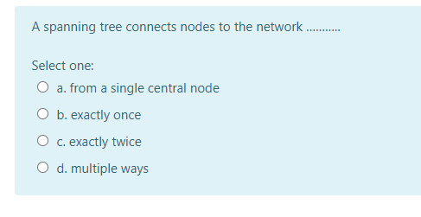
A spanning tree connects nodes to the network .........
Select one: O a. from a single central node
O b. exactly once O c. exactly twice O d. multiple ways

